

Figure 1: Total number of ratings ordered by the number of stars.



Figure 2: The 10 most popular movies



Figure 3: Best rated movies.

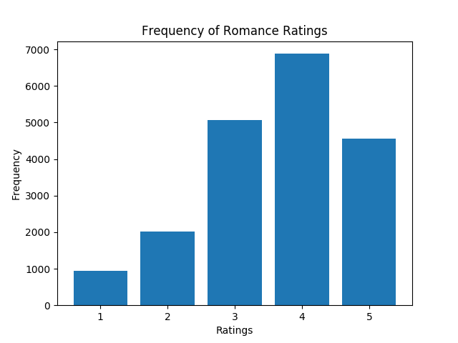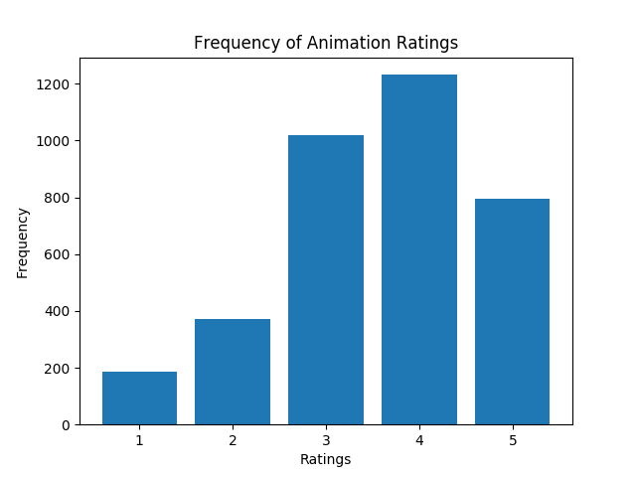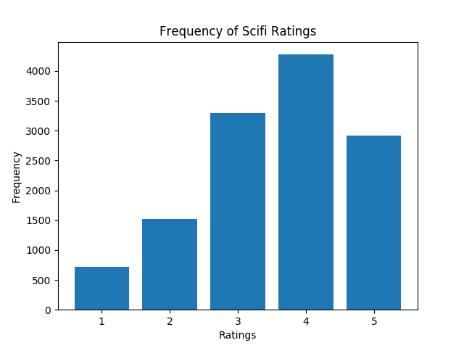

Figure 4: All ratings in the Animation, Romance, and Sci-Fi ratings.

**Plot generated by homework 5 model with no bias**

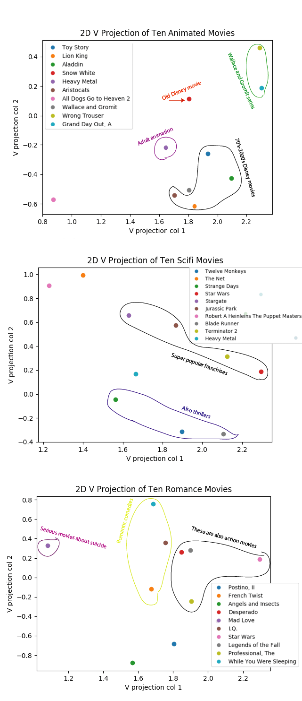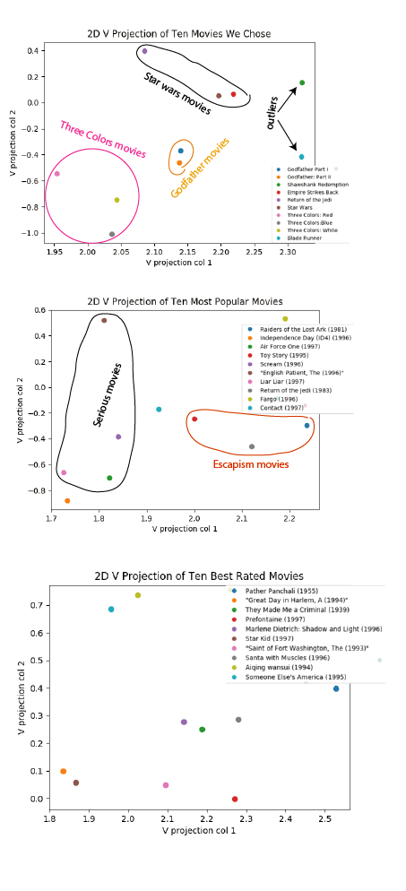

Figure 5: Plots of 10 random movies, 10 most popular movies, 10 best movies, 10 movies from the Anime, Sci-Fi, and Romance genres using the homework 5 model with no bias.

**Plots generated by homework 5 model with bias**

****Figure 6: Plots of 10 random movies, 10 most popular movies, 10 best movies, 10 movies from the Anime, Sci-Fi, and Romance genres using the homework 5 model with bias. We also have 2 extra graphs showing the comparison between popular and best movies as well as movies from the three genres.

**Plots generated by off-the-shelf-implemention**

Figure 7: Plots of 10 random movies, 10 most popular movies, 10 best movies, 10 movies from the Anime, Sci-Fi, and Romance genres using the off-the-shelf implementation. We also have 2 extra graphs showing the comparison between popular and best movies as well as movies from the three genres.

